**TRAINING**&

INSTALLATION

Table of Contents

**Overview**............................................................................................................................................. 3

Introduction......................................................................................................................... 3

Target Users......................................................................................................................... 3

Prerequisites ...................................................................................................................... 3 **Processes**............................................................................................................................................ 4

File Formats......................................................................................................................... 4

File Conversion................................................................................................................... 4

Multi-File Conversion .................................................................................................... 5

Database Viewing ........................................................................................................... 6

**Interfaces**............................................................................................................................................ 7

General Interface.............................................................................................................. 7

Database Interface.......................................................................................................... 7

FileMenu Interface.......................................................................................................... 8

Multi-File Dialog Interface.......................................................................................... 8

**TroubleShooting**

Error Messages................................................................................................................... 9  
 Instructional Videos………………………………………………………………………………………... 9

**About**

Repository.............................................................................................................................. 10 **Legal**

Licence..................................................................................................................................... 11

Overview

**Introduction**

This manual provides information related to the installation, operation, and use of the Conversion software built by the Cosc591 Trimester 1 group.

**Targeted users**

Any individual reading this document or any university staff or personnel who are working with or on the “gait project”.

**Prerequisites**

Before continuing with the installation of this software, please confirm that you comply with the minimum system requirements below

* Java 8 , Version 1.8.0_91 or above
* A Windows 7, Macintosh or Linux Machine
* At least 50 MB of hard disk space
* Processor: pentium 90 Mhz or Faster
* Graphics: SVGA
* Elevated User Control

Processes

**File Formats**

The software will accept **.csv**, **.txt**, **.tsv** formats for the importation process, however it will only export **.csv** to the database for final storage.

**File Conversion**

To convert a file to the correct **.csv** format and file extension, first navigate to either the “Open” button located at the bottom left of the program or *“Open File”* located under the *“File”* menu tab in left of the program. Once clicked a *“File Dialog”* will be displayed to the user, simply navigate to the file that you wish to import and click on the file you wish to import and press the *“Open”* button located at the bottom right of the *“File Dialog”*.   
  
You will notice that the “*File Field*” will now be populated with the directory path from your selected file. Now you must populate the *“Name”* , *“Speed” and “Trial”*  fields located at the bottom of the program. Note that both the *“Speed” and “Trial”* fields are integer sensitive, so only ensure that you populate them with characters **[0-9]**.

Once all fields have been correctly populated simply click the “*convert”* button located at the bottom of the program and the file should now be converted and stored in the database. To view the database click on the database tab.

**Multi-File Conversion**

To convert multiple files to the correct **.csv** format and file extension, first navigate to “*Open Multiple Files”* located under the *“File”* menu tab in left of the program. Once clicked a *“Multi-File Dialog”* will be displayed to the user. By default there is only one file import structure generated, by pressing the “*+”* button located at the bottom of the structure, additional fields will appear. Press the *“+”* button until the desired number of fields are created, note that if you have too many fields, pressing the *“-”* button will delete a field.

Clicking on the *“Open File”* button will once again bring you to a file dialog. Navigating through this dialog and selecting the desired file will populate the file field. Do this for all files desired to be converted, and once completed, populate the *“Name”, “Speed” and “Trial”* fields with the appropriate data. Once again note, that all of the *“Speed” and “Trial”* fields are Integer sensitive, so only ensure that you populate them with characters **[0-9]**. If any fields are unpopulated or if the parser thinks they contain illegal characters, an error message will appear. Make sure that any unused multi-imports are removed using the *“-”*button otherwise the parser will consider them to be “empty” and will not convert the files.  
  
Once all the files have been selected and all of the fields correctly populated, press the convert button, if done correctly the mult-file window will disappear and you will be presented with the first file displayed on the main tab. If you would like to view the database, clicking on the database tab will take you there.

**Database**

To view the database, simply click on the *“database”* tab located in the middle left of the screen. This will take you to the database view, where you can see the screen divided up into three sections. If you see nothing in any of the sections, this means that no data has been imported into the database yet. If data has been imported you will notice on the left hand side a single list view of the database, clicking on the *“Database”* top level of the tree will expand it.

The database consists of *“names”* each name corresponds to a folder created in the database for that participant. From the top down, it should read   
   
 > Database  
 > Name of the participant  
 > Trial x

> Trial y

> Trial z

Clicking on a name, will display a temporary graph on the right most section, this will be implemented with data about the participant at a later date. Clicking on any file with a **.csv** extension will show the data in the middle most section of the program. This data is not currently editable, but will be updatable at a later date.

Interfaces

**General Interface**

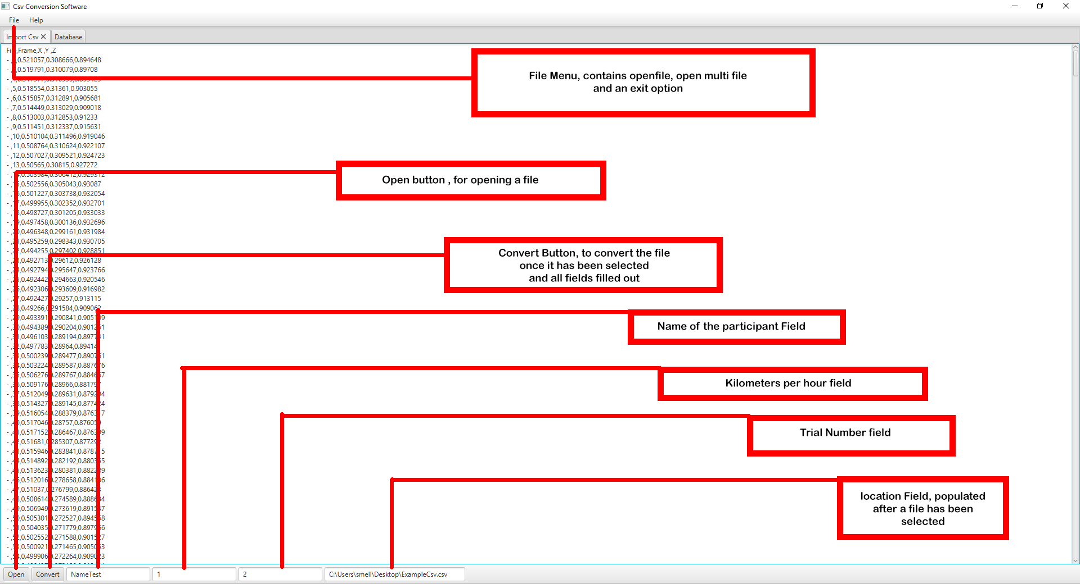

**Database Interface** 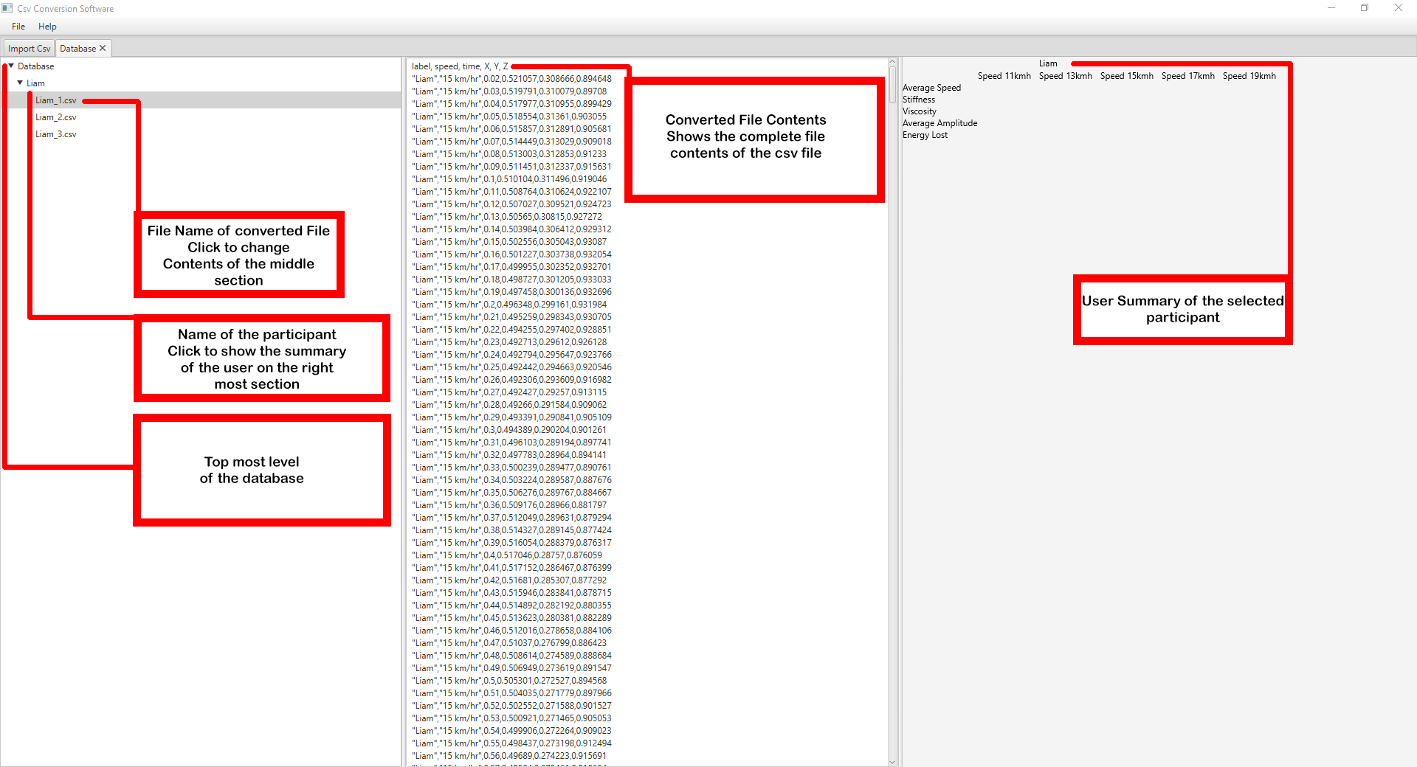

**FileMenu Interface**

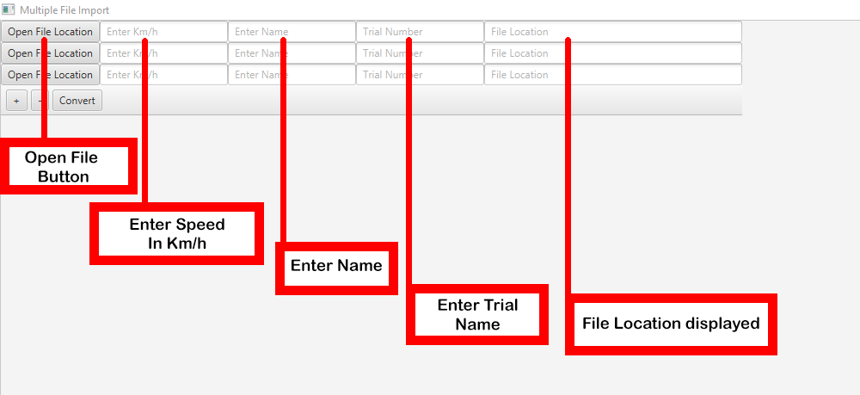

**Multi-File Dialog Interface**



TroubleShooting

**Error Messages**

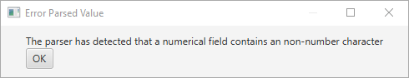

This error indicates that one of the field(s) (Either a speed or a trial) contains an Illegal Character (Something other than **[0-9]**).

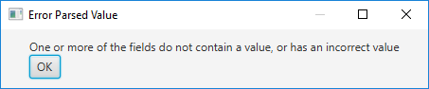

This error indicates that one of the field(s) that is required for the conversion process is either empty or that the “Location field” is not a valid path.

**Instructional Videos**

There are some recorded videos about general use of the software located at the following link, they include how to view the database, how to convert a single file and how to convert multiple files:

<https://github.com/DefinitelyNotASquid/UNE-CSV-Conversion-Software/tree/master/Cosc591/User%20Manuals%2C%20Video%20Recordings%2C%20Images/Videos>

About

**Repository**

The code repository is stored at this link:

<https://github.com/DefinitelyNotASquid/UNE-CSV-Conversion-Software/tree/master/Cosc591/Project%20Source%20Code/Convert>

A download of the entire project is also available at this link:

<https://github.com/DefinitelyNotASquid/UNE-CSV-Conversion-Software>

Legal

**Licence**

Copyright 2018 Liam Carney  
  
Permission is hereby granted, free of charge, to any person obtaining a copy of this software and associated documentation files (the "Software"), to deal in the Software without restriction, including without limitation the rights to use, copy, modify, merge, publish, distribute, sublicense, and/or sell copies of the Software, and to permit persons to whom the Software is furnished to do so, subject to the following conditions:  
  
The above copyright notice and this permission notice shall be included in all copies or substantial portions of the Software.  
  
THE SOFTWARE IS PROVIDED "AS IS", WITHOUT WARRANTY OF ANY KIND, EXPRESS OR IMPLIED, INCLUDING BUT NOT LIMITED TO THE WARRANTIES OF MERCHANTABILITY, FITNESS FOR A PARTICULAR PURPOSE AND NON INFRINGEMENT. IN NO EVENT SHALL THE AUTHORS OR COPYRIGHT HOLDERS BE LIABLE FOR ANY CLAIM, DAMAGES OR OTHER LIABILITY, WHETHER IN AN ACTION OF CONTRACT, TORT OR OTHERWISE, ARISING FROM, OUT OF OR IN CONNECTION WITH THE SOFTWARE OR THE USE OR OTHER DEALINGS IN THE SOFTWARE.